THE GLOBAL BASIC OBSERVING NETWORK (GBON)

1. INTRODUCTION

The WMO Global Basic Observing Network (GBON), designed and defined at a global level, is the basic surface-based observing network that is essential to support Global Numerical Weather Prediction (NWP) [*Johnson*]. The GBON [*Johnson*] is a subset of the surface‑based subsystem of the WMO Integrated Global Observing System (WIGOS), used in combination with the space‑based subsystem and other surface‑based observing systems of WIGOS, to contribute to meeting the requirements of Global NWP [*Johnson*], including reanalysis in support of climate monitoring.

Over the last several decades, NWP has emerged as the common foundation of all weather and climate services for nations big and small.

Thus, Members are increasingly depending on model data products provided by global and regional modelling and prediction centres for the generation and delivery of services to their constituencies. However, these centres and products are in turn completely reliant on a constant supply of reliable observations from all parts of the globe to ensure the quality of their weather and climate products.

**Figure 1.1. Surface land pressure observations received by one or more WIGOS Monitoring Centres (global NWP centres contributing to WDQMS – DWD, ECMWF, JMA and NCEP)  
on 2 January 2023, 00Z.**

(Colour coding is against GBON baseline requirements: fully reporting stations shown in green, partly reporting stations in orange or red, silent (non-reporting) stations in black, stations that report at the frequency greater than required by GBON in pink [*Johnson*]).

Currently, large gaps exist over land and sea where essential surface-based observations are missing. For instance, missing surface-pressure observations available to WIGOS Monitoring Centres (global NWP centres contributing to WDQMS) are shown here (see map, above) in black dots. Red or orange dots show where observations are available but are not currently shared internationally at the required temporal frequency.

In response to the persistent geographical gaps in data coverage, the adoption of the GBON by the WMO Members represents a new approach in which the basic surface-based observing network needed to feed the NWP models with input data is designed, defined and monitored at the global level.

Improvements in the international exchange of observational data due to GBON will flow through the weather value chain to deliver benefits that are estimated to amount to more than US$ 5 billion annually (see in [The value of Surface-Based Meteorological Observation Data: Costs and benefits of the Global Basic Observing Network](https://library.wmo.int/index.php?lvl=notice_display&id=21770#.YcM1KxOZPX1)).

The benefits of increasing surfaced-based observations through GBON will be felt most over areas from which observations are currently missing, including some of the regions that are most vulnerable to climate change and its impacts. However, given the global nature of weather and climate, benefits of GBON will be realized both in the countries where the improvements are made and across the globe.

In order for the WMO Members to fully implement GBON and realize the benefits mentioned above, additional investment and capacity development will be needed for many developing countries. WMO is therefore working closely with the international development and climate finance communities to facilitate this, including the establishment of the Systematic Observations Financing Facility ([SOFF](https://alliancehydromet.org/soff/)). More information on how SOFF is working to help close the GBON gap can be found [here](https://library.wmo.int/index.php?lvl=notice_display&id=21771#.YcNfohOZPX3).

The provisions in the [*Manual on the WMO Integrated Global Observing System*](https://library.wmo.int/doc_num.php?explnum_id=11157#page=77) (WMO–No. 1160), section 3.2.2 Global Basic Observing Network, are based on current observational requirements for global NWP as defined by technical experts working under the WMO Commission for Observation, Infrastructure and Information Systems (INFCOM) and the Global Climate Observing System. Drawing on more than 20 years of NWP observational data impact studies coordinated by WMO, the provisions specify – in clear, quantitative terms – the obligations of WMO Members to acquire and exchange these critically needed observations: which parameters to measure, how often, at what horizontal and vertical resolution, and which measurement techniques to use.

Satellites provide global coverage and can measure parameters for both atmosphere and surface, and satellite data make a very substantial contribution to forecast skill. However, global NWP systems still have a critical reliance on surface-based observations for certain key parameters that cannot yet be reliably measured from space: in particular atmospheric surface pressure, the vertical distribution of winds and subsurface ocean parameters. Surface-based observations are essential over land, over snow and ice surfaces, they are essential tools for verification of model predictions, and they play critical roles for calibration and validation of space-based data.

Given the critical role of surface-based observations and the persistent gaps in the surface-based observing networks, the GBON regulations currently encompass surface-based data only. The implications of the WMO Unified Data Policy for satellite data are still being elaborated between WMO and the satellite operators.

2. GBON REQUIREMENTS

2.1 GBON standard requirements

The overall purpose of GBON is to secure adequate supply of observational data to the global NWP centres that serve all Members with model products. “Adequate supply” means (i) measurement of the most important variables, (ii) measurements made at a sufficient spatial density, and (iii) measurement reported at a sufficient temporal frequency.

The variables to be observed by Members at a set of surface land stations/platforms are, at a minimum, atmospheric pressure (SLP), air temperature (T), humidity (H), horizontal wind (W), precipitation (P) and snow depth (SD), where applicable.

The variables to be observed by Members at a set of upper-air stations/platforms over land are, at a minimum, air temperature (T), humidity (H) and horizontal wind (W).

The variables to be observed by Members at a set of surface marine meteorological observing stations/platforms within their Exclusive Economic Zone, or the corresponding marine areas of their jurisdictions, are, at a minimum, atmospheric pressure (SLP) and sea surface temperature (SST).

Table 2.1 below provides a summary of station-level GBON requirements for different types of observing stations in terms of space and time requirements according to the “shall” (bold) and “should” provisions of GBON.

**Table 2.1. Summary of GBON requirements for different types of observing stations, ‘shall’ provisions in bold type.**

|  | **Horizontal Resolution** | **Vertical Resolution** | **Observing cycle** | **Variables** | **Other requirements** |
| --- | --- | --- | --- | --- | --- |
| **Surface land stations** | **200 km** 100 km[1] | n/a | **1 h** | **SLP, T, H, W, P, SD** | **Exchanged in real time through WIS2** |
| **Upper-air stations operated from land** | **500 km** 200 km1 | **100 m** | **2/24 h** | **T, H, W** | **Up to 30 hPa, exchanged in real time through WIS-2** |
| **Subset of upper-air stations** | 1000 km[2] | 100 m | 24 h | T, H, W | Up to 10hPa, Exchanged in real time through WIS2 |
| **Surface marine stations in Exclusive Economic Zones** | **500 km** | n/a | **1 h** | **SLP, SST** | **Exchanged in real time through WIS 2** |
| **Upper-air stations operated in Exclusive Economic Zones** | **1000 km** | **100 m** | **2/24 h** | **T, H, W** | **Up to 30 hPa, exchanged in real time through WIS 2** |
| **Aircraft data** | 100 km at flight level | 300 m for profiles | 1 h | T, H, W | Data exchange per licensing agreement |
| **Remote sensing profiler observations** | Where available | 100 m | 1 h | T, H, W | n/a |

**2.2 GBON high density network requirements**

GBON high density requirements apply where Members operate networks of surface land observing stations/platforms at horizontal resolutions of 100 km or higher, and networks of upper-air stations/platforms providing horizontal resolutions of 200  km or higher. According to GBON provisions 3.2.2.8 and 3.2.2.13 Members should operate their networks at such density. At the same time, provisions 3.2.2.9 and 3.2.2.16 respectively, state that Members who do operate at these higher densities shall make such data available internationally through WIS all GBON observations in real time or near‑real.

Accordingly, for surface land observing networks, GBON compliance monitoring will be performed against both 200 km standard density and 100 km high density requirement, providing two distinct targets regardless of whether Members are operating their networks in the standard or high density configuration.

Similarly, for upper-air networks, the GBON compliance monitoring will be performed against both 500 km standard density and 200 km high density requirement.

GBON compliance reports will then show which countries are operating their surface land and upper-air networks at high density and which country are operating them at standard density configuration.

## 3. DESIGNATION OF GBON STATIONS

**3.1 Process for the designation of GBON stations**

The composition of GBON, updated according to the proposals of Members with regard to the designation of GBON stations, is regularly approved by INFCOM.

Members have the authority to nominate stations in GBON, either on the basis of the global gap analysis or one performed by them.

The process to be followed by all stakeholders for the designation of GBON stations is regulated according to Appendix 3.1 of the Manual on the [Manual on the WMO Integrated Global Observing System](https://library.wmo.int/index.php?lvl=notice_display&id=19223) (WMO‑No. 1160) and is reproduced here for convenience.

*(Editorial note: the text below will be updated accordingly to be consistent with the Manual through the Resolution 3.2(1)/1 (EC-76).)*

1. The list of GBON stations/platforms is drawn from the list of the available stations/platforms in WIGOS as registered in the Observing Systems Capability Analysis and Review tool for surface-based observations ([OSCAR/Surface](https://oscar.wmo.int/surface/)) by the Members, and monitored by the WIGOS Data Quality Monitoring System (WDQMS) web tool for data quality.

2. The identification of the subset to be proposed by Members for GBON designation is based on provisions 3.2.2.7–3.2.2.10 and 3.2.2.12–3.2.2.15.

3. The list of GBON stations/platforms is elaborated in collaboration between the Members and INFCOM.

4. INFCOM undertakes a regular analysis of the status of the GBON implementation that provides, for each Member, the number of surface stations and the number of upper-air stations that are required for the Member to meet their obligations under 3.2.2.7–3.2.2.10 and 3.2.2.12–3.2.2.15.

5. For each Member, INFCOM reviews their designated contribution as per 3.2.2.21 and assesses whether it meets the requirements specified in 3.2.2.7–3.2.2.10 and 3.2.2.12–3.2.2.15, and informs the Member in writing of its findings.

6. For the maintenance of GBON, the proposed designation (or removal) of GBON stations by Members is made and recorded in [OSCAR/Surface](https://oscar.wmo.int/surface/) by their National Focal Points for OSCAR/Surface. All designated GBON stations will then automatically appear on the dedicated GBON webtool. The stations designated by Members in [OSCAR/Surface](https://oscar.wmo.int/surface/) are recorded with “Pending Approval” status with regard to their GBON affiliation.

7. President of INFCOM, assisted by the Secretariat, reviews the proposed designations and prepares the draft Resolution to INFCOM on the updated GBON composition and makes it available to all Members three months before the INFCOM Session.

8. Based on the feedback provided by Members, a final version of the draft Resolution on the GBON composition is submitted to INFCOM for approval.

INFCOM then decides on the GBON composition on the basis of the list of designated GBON stations visible in the [GBON web tool](https://community.wmo.int/global-basic-observing-network-gbon-station-designations-map) at the time of its session. Adjustments are possible during the session after which the updated version of the GBON composition is approved by INFCOM. At this stage, the stations with “Pending Approval” status with regard to their GBON affiliation are turned to “Approved” status by the Secretariat on the basis of the actual INFCOM decision. The president of INFCOM is also authorized during the INFCOM intersessional period to approve small adjustments of the GBON composition on behalf of the Commission.

To facilitate the designation process, Members are urged to undertake the actions listed below:

1. Ensure that a national Focal Point for OSCAR/Surface is nominated and has the authority to designate GBON stations (see the [list of designated national focal points](https://community.wmo.int/governance/commission-membership/commission-observation-infrastructure-and-information-systems-infcom/commission-infrastructure-officers/infcom-management-group/standing-committee-earth-observing-systems-and-monitoring-networks-sc/national-focal-points)).
2. Regularly conduct a national gap analysis against GBON requirements (see guidelines and template in section 4 on the Management of GBON).
3. Set and update their national targets for GBON and their National GBON Contribution Plan (see guidelines in section 5.3).

**3.2 Removal of GBON affiliation from GBON stations**

Members may wish to remove GBON affiliation from GBON stations for the following reasons: the station is no longer operational; the station was moved to another location and assigned a different WIGOS Station Identifier; the National Meteorological and Hydrological Services (NMHSs) or partner organization operating the station is no longer in capacity to operate the station according to GBON requirements; the station duplicates other GBON stations, etc. In such cases, the stations are not removed from [OSCAR/Surface](https://oscar.wmo.int/surface/), and their affiliation to GBON is neither deleted: the OSCAR/Surface NFP must only indicate the date at which GBON affiliation stops in [OSCAR/Surface](https://oscar.wmo.int/surface/). Removal of GBON affiliation from GBON stations is also subject to approval by INFCOM.

**4. GBON COMPLIANCE**

The definition of GBON compliance includes two parts: (a) Station-level compliance, and (b) Member-level compliance.

1. Station-level compliance

It is achieved when a given station reports the required measurements, at the required temporal frequency, with the required reporting quality.

1. Member-level compliance

It is achieved when a given Member is operating a sufficient number of compliant GBON stations to satisfy the horizontal density requirements.

All GBON stations must be registered in [OSCAR/Surface](https://oscar.wmo.int/surface/) and include the network affiliation to GBON.

### 4.1 General considerations

**4.1.1 Network Density/Coverage**

The stations are nominated to a network which by design delivers the required density/horizontal coverage. Assessing density/horizontal compliance through regular monitoring of stations reporting would be very complex, so the approach will be to assign a number of stations to each country/territory which might include some redundancy, and then do the assessment on whether the number of compliant stations is equal to/greater than the number expected.

**4.1.2 Availability**

Currently, the primary performance measure for assessing WMO observational compliance is based on data availability with the following generally accepted practices:

* Most WMO networks are monitored by stations reporting to an international data centre (i.e., reports received rather than observations made)
* Daily/Weekly/Monthly compliance monitoring tends to be against total number of reports for the period, rather than specifically to the temporal requirements
* Most monitoring only assesses whether a report has been received or not, rather than assessing the content of the report
* The WDQMS web tool uses statistics generated by the WIGOS Monitoring Centres (global NWP centres) and thus is able to assess against the different variables within the reports
* Not all stations will necessarily report all the GBON mandatory variables

The GBON upper-air requirements include also criteria on vertical range (burst height and resolution) which are not always able to be assessed in availability statistics.

**4.1.3 Timeliness**

All reports must be sent in near-real time over WIS. For example, if data is not received by the NWP centres by a certain time it cannot be used. At a national level, and for some regional activities (e.g. EUMETNET), the timeliness has been agreed primarily to align with the NWP assimilation runs and the cut-off to use the measurements.

It is planned that the WIS 2 will attribute ‘time of receipt’ to received reports, which will allow the timeliness to be calculated by comparing with the time of the observations. Once implemented this will be considered in a future upgrade of the WDQMS web tool.

Regardless how delayed a report is, there are some applications (i.e., Reanalysis and Climate Monitoring) which can still make use of the data. However, some of the data routing processes have a fixed time cut-off (i.e. > 24 hours) beyond which the report is automatically rejected.

**4.1.4 Quality**

If reported data is not of sufficient quality than the NWP systems will reject the data. In addition, if sufficient metadata are not recorded in the [OSCAR/Surface](https://oscar.wmo.int/surface/) database then this will directly impact on the quality monitoring of GBON.

Most reports of surface (land and marine) and upper-air (land and marine) stations contain no information about the quality of the measurements. Often, the operational processes and instrumentation used have an implied quality, which has been assessed through intercomparisons and test campaigns.

Most operational quality monitoring of these systems is undertaken as a quality evaluation process by comparing the measurements against a back-ground field (i.e. NWP model) and computing statistics of OB-FG (Observation – First Guess field) or OB-AN (Observation – Analysis).

The NWP assimilation also has a rejection process so as not to allow gross errors to negatively impact the quality of the model products. The rejection criteria are often much more relaxed than the ‘threshold’ limits in the WMO RRR but this can be useful in identifying stations/platforms with gross errors.

**4.1.5 Format**

According to the [Manual on the WMO Integrated Global Observing System](https://library.wmo.int/index.php?lvl=notice_display&id=19223) (WMO‑No. 1160), 2.4.4.1, Members shall report and make available observations in real time through the WMO Information System (WIS) in the standard formats specified by the [*Manual on Codes*](https://library.wmo.int/index.php?lvl=notice_display&id=13617#.Y7_MdXbMI2w) (WMO‑No. 306), Volumes I.1, I.2 and I.3., e.g. the Binary Universal Form for the Representation of meteorological data (BUFR). For example, minimum 100-m vertical resolution of the upper-air measurements requires that the measurements are taken every 20 s which can only be achieved through the complete BUFR code.

### 4.2 Station-level compliance monitoring

**4.2.1 Station-level compliance criteria**

The compliance criteria to be met for each GBON Surface Land or marine station/platform are presented in Table 4.1, while those for GBON upper-air land and marine stations are shown in Table 4.2. The criteria are applicable for each measured variable defined in section 2.1.

**Table 4.1: Compliance criteria for GBON Surface – land and – marine meteorological observing station/platform**

|  |  |  |  |
| --- | --- | --- | --- |
| **Mark** | **Name** | **Description** | **Criteria** |
| SSL 1 | Monthly Availability (%) | No. of received monthly reports[3] / (Days per month * 24[4]) Monthly | ≥ 80% |
| SSL 2 | Timeliness (%) | No. of late [*Secretariat*] reports[5] / (Days per month * 24) | < 5% |
| SSL 3 | Monthly Quality (%) | No. of rejected monthly reports[6] / (Days per month * 24) | < 5% |

**Table 4.2: Compliance criteria for** **GBON Upper-air – land and  
-marine observing station/platform**

|  |  |  |  |
| --- | --- | --- | --- |
| **Mark** | **Name** | **Description** | **Criteria** |
| SUA 1 | Monthly Availability (%) | No. of received monthly profile (to 30hPa) reports[7] / (Days per month * 2[8]) | ≥ 80% |
| SUA 2 | Vertical Resolution[9] (Y/N) | Vertical resolution is at least 100 m | Yes |
| SUA 3 | Timeliness (%) | No. of late [*Secretariat*] reports[10] / (Days per month * 2) | < 5% |
| SUA 4 | Monthly Quality (%) | No. of rejected monthly reports[11] / (Days per month * 2) | < 5% |

**4.2.2** **GBON station compliance assessment**

For the initial phase of GBON a subset of the compliance criteria from the above section is limited to surface land stations and upper-air stations on land for the assessment of station compliance.

To enable compliance assessment a GBON station must be registered in [OSCAR/Surface](https://oscar.wmo.int/surface/) and include the network affiliation to GBON. If the station does not meet this requirement it will be assessed as non-compliant.

For the time being, a surface-land observing station/platform is found as GBON compliant if all three criteria (SSL 1 – SSL 3) from Table 4.1 are met for, at least, the measurement of atmospheric pressure.

For the time being, an upper-air land observing station/platform station is found as GBON compliant if all four criteria (SUA 1 – SUA 4) from Table 4.2 are met for, at least, the measurement of air temperature [*Secretariat*].

### 4.3 Member-level compliance monitoring

**4.3.1 Member-level compliance criteria**

Compliance criteria to be met on Member level, compare a number of the Member’s stations that meet station compliance criteria described in section 4.2.1 and a number of stations estimated by the GBON global gap analysis (GGGA). The criteria are as follow:

**M1: Surface land GBON compliant stations (SLGCS)**

Number of Member’s Surface-land GBON compliant stations (SLGCS) is greater than, or equal to, required number of Surface-Land GBON stations (SLGS) from GGGA:

No. of SLGCS ≥ Required No. of SLGS from GGGA

**M2: Upper-air land GBON compliant stations**

Number of Member’s Upper-air land GBON compliant stations (UALGCS) is greater than, or equal to, required number of Upper-air land GBON stations from (UALGS) from GGGA:

No. of UALGCS ≥ Required No. of UALGS from GGGA

**4.3.2** **GBON Member compliance assessment**

GBON Member compliance is assessed towards the criteria M1 and M2 from section 4.3.1 on a monthly basis.

Member is found as GBON Compliant only if both criteria are met.

Note: Under certain circumstances, for example when a Member territory is rather small or of an irregular shape, some GBON compliant stations of the neighbouring Members can be included in the Member’s compliance assessment. If this is that case, then the Member concerned must provide a written prove that the neighbouring Members are in agreement to include their stations in GBON assessment of that particular Member and report to the Secretariat on that, as described in section 4.5.

**4.4**  **Compliance status and reporting**

Compliance of GBON at station and Member levels will be routinely assessed and made available, using tools such as the WDQMS web tool. Station-level compliance results, aggregated on a monthly basis, will be automatically produced and made available online from the WDQMS web tool, while Member level assessments will be undertaken and provided on a quarterly basis by the INFCOM Standing Committee on Earth Observing Systems and Monitoring Networks (SC-ON) assisted by Secretariat, on the basis of data provided by the WDQMS web tool. It is recommended that Members review these quarterly assessments and take action if needed. The Regional WIGOS Centres (RWCs) will also assist in this regard by alerting Members on non-compliance issues and discovered incidents. An annual compilation of national GBON assessment reports based on the Members’ quarterly assessments, taking into account Members’ feedback if available, will be produced by SC-ON assisted by the Secretariat and published.

Members are invited to be aware of their compliance status and undertake their own compliance monitoring with the goal to evolve their observing networks towards full GBON compliance if this is not already the case.

4.5 Exemption per Article 9 of the WMO Convention

Compliance status of Members invoking Article 9 of the WMO Convention

Article 9(b) of the WMO Convention published in the [*Basic documents No. 1*](https://library.wmo.int/index.php?lvl=notice_display&id=14206#.Y0gbdXZBw2w) (WMO-No. 15) states that “*If … any Member finds it impracticable to give effect to some requirement in a technical resolution adopted by Congress, such Member shall inform the Secretary-General of the Organization whether its inability to give effect to it is provisional or final, and state its reasons therefor”*.

The [*Technical Regulations*](https://library.wmo.int/index.php?lvl=notice_display&id=14073) (WMO‑No. 49), Volume I, General Provisions, paragraph 6 states that *in accordance with the above definitions, Members shall do their utmost to implement the standard practices and procedures. In accordance with Article 9 (b) of the Convention and in conformity with Regulation 101 of the General Regulations, Members shall formally notify the Secretary-General, in writing, of their intention to apply the standard practices and procedures of the Technical Regulations, except those for which they have lodged a specific deviation. Members shall also inform the Secretary-General, at least three months in advance, of any change in the degree of their implementation of a standard practice or procedure as previously notified and the effective date of the change.*

Accordingly, the following conditions, criteria and implications on compliance status of a Member invoking Article 9(b) [*Secretariat in consultation with SOFF]* concerning their contribution to GBON are as followed:

* Concerning the horizontal resolution requirement, a Member invoking Article 9(b) concerning their commitment to GBON should clearly indicate the reasons, for what part of their territory they are seeking exemption to meeting GBON requirements, their level of commitment to meeting GBON horizontal resolution requirement for the rest of their territory, the period during which they believe such part of their territory would be exempted, and whether they have any plan to improve the situation
* Concerning the temporal resolution requirement, a Member invoking Article 9(b) concerning their commitment to GBON should clearly indicate what subset of their GBON observing stations will not be meeting the temporal resolution requirements, the reasons why the requirement cannot be met, the period during which they believe such subset of stations would be exempted, and whether they have any plan to improve the situation

An independent committee of experts designated by the INFCOM president in consultation with the INFCOM management group will assess whether a Member claiming Article 9(b) should be regarded as GBON compliant on the basis of the following criteria:

1. The reasons stated by the Member are regarded as legitimate;
2. There is substantial part of the Member territory compliant to GBON horizontal requirements (for small countries, if the horizontal requirement for GBON is met thanks to commitment of surrounding countries to GBON, the country may still be regarded as GBON compliant if it is at least committing one observing station to GBON);
3. There is substantial number of GBON stations committed by the Member that comply with GBON temporal resolution requirements.

If the independent committee of experts considers that the Member is GBON compliant, such status will be reflected in the overall compliance status of all Members. In the contrary, the Member will be informed about its non-compliance status by the Secretary-General, and be urged to take steps to become compliant. The INFCOM president will inform the Executive Council about the independent committee decision.

5.  MANAGEMENT OF GBON

**5.1 Roles and responsibilities**

Table 5.1 below clarifies the roles and responsibilities of main stakeholders concerning the process for establishing the initial composition of GBON. Responsibilities of national focal points are detailed in the [Guide to the WMO Integrated Global Observing System](https://library.wmo.int/index.php?lvl=notice_display&id=20026) (WMO‑No. 1165), Chapter 6, Annex 1.

**Table 5.1: Roles and responsibilities of main stakeholders in establishing initial composition (January 2023) of GBON**

| **Stakeholder or group** | **Role** |
| --- | --- |
| Members | * Nominate WIGOS, OSCAR/Surface and WDQMS National Focal Points and brief them on their role in support of GBON implementation; make sure they will get appropriate support from their management to undertake their role. * Consider GBON requirements, identify opportunities for committing GBON stations and filling identified gaps, implement GBON requirements, and take action as needed for complying with them: * Review GBON compliance assessment reports and take action as needed. * Nominate additional GBON stations, including for example existing stations not currently reporting internationally or those from partner organizations for which a Memorandum of Understanding (MoU) at national level could be negotiated and established to commit their stations to GBON. * Least developed and Small Island Developing States (SIDS) to apply for SOFF funding. * Other Developing Countries to make use of capacity development opportunities, including SOFF technical support when applicable. |
| WIGOS Monitoring Centres (global NWP centres contributing to WDQMS) | * Assimilate GBON data and provide the information needed for the WDQMS web tool on the GBON compliance monitoring |
| WIGOS National Focal Points | * Contribute to the design of GBON and identify the existing or new GBON stations to be committed by their Country/Territory and promote or coordinate the necessary actions nationally to reach such commitment. * Perform a National GBON Gap Analysis and inform the WMO Secretariat on their Country/Territory capabilities and possible non-achievable requirements. * Negotiate with partner organizations & encourage non-NMHS observing stations to be made available when they meet GBON requirements. |
| OSCAR/Surface National Focal Points | * Make sure that candidate GBON stations WIGOS metadata are recorded and kept updated in OSCAR/Surface |
| WDQMS National Focal Points | * Check and monitor compliance of GBON stations nationally, using the WDQMS web tool and address any incident that may have been reported by the Regional WIGOS Centre. |
| Regional WIGOS Centres (RWCs) | * Monitor compliance of GBON observing stations with GBON requirements, and alert Members via their WDQMS NFPs about identified incidents. |
| Regional associations working groups on Infrastructure | * Promote regional cooperation and exchange of data across political boundaries – share benefits, share space, propose prioritization mechanism(s) for such cooperation, e.g., in support of disaster risk reduction; facilitate exchange of GBON data using existing global and regional infrastructure (e.g. WIS centres, WIS 2.0 in a box). |
| WMO Secretariat | * Provide technical support to INFCOM teams for the design of GBON composition and GBON compliance monitoring, including: * Liaison with WIGOS NFPs to get information on Members’ capabilities, and what candidate observing stations they wish to commit to GBON. * Perform global gap analysis and make proposal on the designation of GBON stations. * Propose update to guidance material on GBON as needed. * Look at how to make the best use of WIGOS tools (WDQMS, OSCAR/Surface), and assist INFCOM teams on how these tools should evolve or be used for GBON. * Assist SC-ON with station and Member level assessments and the production of corresponding reports. * Assist INFCOM teams on producing Members level assessment reports (quarterly and annually), as well as other relevant related tasks. |
| SOFF Secretariat | * Coordinate the implementation of SOFF according to the SOFF Secretariat Terms of Reference. * Provide support to Members concerning the understanding of SOFF operational elements in support of GBON implementation to fill the gaps. * Collaborate with WMO Secretariat and the INFCOM teams to develop and provide specific guidance and training for SOFF peer advisors. * Collaborate with WMO Secretariat and the INFCOM teams in identifying GBON country opportunities for SOFF programming decision making. * Collaborate with WMO Secretariat and INFCOM teams in establishing the WMO functions as SOFF Technical Authority. * Collaborate with WMO Secretariat and the INFCOM teams in developing specific WDQMS reports, or OSCAR/Surface features for SOFF. |
| INFCOM President | * Reviews the recommended list of GBON stations to be included in the network initial composition in consultation with the management group and the SC-ON Chair in particular. |
| INFCOM Teams | * Produce Members level assessment reports (quarterly and annually) with assistance from WMO Secretariat. * Develop technical guidelines, processes and procedures needed to ensure expedient and efficient implementation of GBON, and to prepare for effective performance and compliance monitoring of GBON. |
| INFCOM session | * Approves GBON composition at its session. |
| Congress | * Adopts the list of GBON stations to be included in the network initial composition (then delegated to INFCOM for the maintenance of GBON). |

**5.2 National GBON Gap Analysis**

To implement GBON at a national level, the Members are encouraged to complete the National GBON Gap Analysis for understanding the gap existing in the required observing networks and allow for identifying their national contributions to the composition of GBON for filling the identified gaps.

The gap analysis is the starting phase for implementing the GBON regulations. The objective of the analysis is to define the gap between the GBON requirements and the existing surface, upper-air and marine observing networks. In other words, it serves as the basis for identifying the number of observing stations that need to be installed or improved to become compliant with the requirements of the GBON regulations.

The guidance provides a step-by-step process for defining the National GBON Gap Analysis per GBON requirement. The results help the Members to assess whether their current network is meeting the requirements, plan actions to upgrade the observing networks as necessary and assign the first stations to the GBON network.

The completed National GBON Gap Analysis serves as the objective and quantitative basis for the preparation of the National GBON Contribution Plan (detailed in 4.4 and Annex 2), which considers the best approaches and activities for complying with the GBON regulations. Section 3.2.1 provides a summary of GBON regulations.

**5.2.1 Gap Analysis steps**

The *global* gap analysis provides a quantitative estimate of the number of surface and upper‑air observing stations over land per country needed in order to meet the GBON requirements. The WMO Secretariat completes the global analysis on which stations are internationally sharing the data based on the information available through the WDQMS web tool. This serves as a baseline for the national assessment of existing observation networks against the target number of stations.

A template for completing the National GBON Gap Analysis Report is available at [References to GBON material](https://community.wmo.int/activity-areas/wigos/gbon/implementation-global-basic-observing-network-gbon/defining-initial-composition-gbon/references-gbon-material). *(Editorial note: will be added there in due course)*.

**Step 1 – Analysis of the GBON horizontal resolution requirements**

In this step, the country-specific GBON horizontal resolution requirements are analysed based on the global GBON gap analysis performed by the WMO Secretariat and the final adjustment by the Member. While the global gap analysis is a simplified analysis, the number of target GBON stations should be reviewed and adjustments done as needed by every Member. The global gap analysis does not include full investigation of Exclusive Economic Zone (EEZ), and therefore, no target number for marine observing stations are given. For Members having EEZ, the initial GBON target needs to be assessed in terms of surface marine observing network. Those Members who have territories in apart locations, should assess the GBON requirements for these territories individually.

Elements in Step 1 (Table 5.2):

1. GBON horizontal resolution requirements: The GBON regulations as published in the [Manual on the WMO Integrated Global Observing System](https://library.wmo.int/index.php?lvl=notice_display&id=19223) (WMO‑No. 1160);
2. GBON target: Number of surface and upper-air stations required based on the GBON global gap analysis completed by the WMO Secretariat and adjusted by the Member as necessary;
3. Reporting: Number of surface, upper-air and marine stations reporting internationally to WIS;
4. Gap improve: Number of surface, upper-air and marine stations that could a priori be improved to meet GBON requirements, for example by increasing the number of shared observations (as default per the Global Gap Analysis);
5. Gap new: Number of new surface, upper-air and marine stations need to be established and installed (as default per the Global Gap Analysis);
6. Gap total: The total of how many stations need to, either be improved, or newly installed (as default per the Global Gap Analysis).

**Table 5.2. GBON network requirements as per the horizontal resolution**

|  |  |  |  |  |  |
| --- | --- | --- | --- | --- | --- |
| GBON horizontal resolution requirements | GBON TARGET | REPORTING | GAP IMPROVE | GAP NEW | GAP TOTAL |
| Surface stations, standard density, 200 km |  |  |  |  |  |
| Surface stations, high density, 100 km |  |  |  |  |  |
| Upper-air stations over land, standard density 500 km |  |  |  |  |  |
| Upper-air stations over land, high density 200 km |  |  |  |  |  |
| Upper-air stations over marine  1000 km |  |  |  |  |  |
| Surface marine stations  500 km |  |  |  |  |  |

Caveats of the global gap analysis results:

1. The reporting threshold for GBON upper-air stations over land was one daily sounding, noting that the GBON requirement is two soundings per day;
2. For SIDS, the EEZ area has been added to the total surface area which is the basis for the target number of stations;
3. The surface area was computed based on a geographic information system model and may slightly deviate from official records.

**Step 2 – Analysis of existing GBON stations and their status against GBON requirements**

In step 2 (Table 5.3), the Member assesses the existing national observing networks and stations. This includes stations operated by the NMHS and other governmental agencies or private sector which could potentially be included to the national GBON network. Stations’ operational status is assessed along with the variables reported and maps provided to indicate the station distribution.

First, the assessment is done for observing networks operated by NMHS and the by third party operators at a network level. The networks are evaluated based on the mandatory GBON requirements as described in the left column of Table 2.1 in 2.1.

The elements to be analysed in step 2 are:

1. **NMHS network:** Number of stations managed by the NMHS. The surface, upper-air and marine stations are assessed and categorized as reporting or to be improved;
2. **Third party networks:** Number of surface, upper-air and marine stations operated by the third party which could contribute to or become GBON stations are assessed and categorized as reporting or to be improved. Not all third party networks are necessarily known, and this element should be assessed based on the best knowledge available;
3. **Station information:** Name and owner of a station, andwhich variables a station is reporting and how regularly (Table 5.4).

The status of existing stations is defined as follows:

* **Reporting:** Whether the operational station measures all GBON variables and exchanges the data to WIS in real-time.
* **Improve:** Whether the station exists but is not fully operational and can be improved to report internationally, (e.g., the station has broken instruments, does not report on the minimum number of required variables at required frequency, or the observations are not exchanged internationally via WIS). Actions for improvements are considered in the National GBON Contribution Plan.

**Table 5.3. Assessment of existent stations per their operational status and network ownership**

|  |  |  |  |  |
| --- | --- | --- | --- | --- |
| GBON Requirements | Existing observation stations (# of stations) | | | |
| NMHS network | | third party network | |
| Reporting | Improve | Reporting | Improve |
| Surface station standard density, 200 km |  |  |  |  |
| Surface station high density, 100 km |  |  |  |  |
| Upper-air stations over land, standard density 500 km |  |  |  |  |
| Upper-air stations over land, high density 200 km |  |  |  |  |
| Upper-air stations over marine 1000 km |  |  |  |  |
| Surface marine stations 500 km |  |  |  |  |

*\*\*\* Placeholder for maps of existing surface and upper-air networks \*\*\**

Secondly, the status of the existing stations is analysed in terms of the GBON variables and international reporting cycle requirements (Table 2.1 in 2.1). The reporting cycle is assessed per station in respect to one-hour reporting frequency for surface and marine stations and twice a day for upper-air stations.

**Table 5.4. Assessment of existing GBON stations per variable and reporting cycle**

|  |  |  |  |  |  |  |  |  |  |  |
| --- | --- | --- | --- | --- | --- | --- | --- | --- | --- | --- |
| Station Name | Station Type (S/UA/M) | Owner (NMHS/ 3rd PARTY) | GBON Variable Measured | | | | | | Reporting Cycle | GBON Compliant (Y/N) |
| SLP | T | H | W | P | SD |
|  |  |  |  |  |  |  |  |  |  |  |
|  |  |  |  |  |  |  |  |  |  |  |
|  |  |  |  |  |  |  |  |  |  |  |
|  |  |  |  |  |  |  |  |  |  |  |
|  |  |  |  |  |  |  |  |  |  |  |
|  |  |  |  |  |  |  |  |  |  |  |

*Station type: S: Surface, UA: Upper-Air, M: Marine;* *Owner of the station: NMHS or which third party; Variables: SLP: Atmospheric pressure; T: Temperature; H: Humidity; W: wind; P: Precipitation; SD: Snow depth; Reporting cycle: Number of observation reports exchanged internationally per day (0–24); summary whether the station is GBON compliant (Y/N)*

**Step 3 – GBON Gap Analysis results**

The results of steps 1 and 2 are summarized to Table 5.5: the number of stations required per GBON regulations (GBON target), number of existing stations compliant with the GBON requirements and new and improved GBON stations needed for surface, upper-air and marine networks are completed.

A map of existing stations is developed with the location of gaps indicated in circles of 200 km (surface) and 500 km (upper-air and marine) radius around the existing stations.

**Table 5.5. Results of the National GBON Gap Analysis**

|  |  |  |  |  |
| --- | --- | --- | --- | --- |
| GBON Requirements | GBON Target | Compliant Stations with GBON | Stations needed against GBON Requirements | |
| New | Improved |
| Surface stations, standard density, 200 km |  |  |  |  |
| Surface stations, high density, 100 km |  |  |  |  |
| Upper-air stations over land, standard density 500 km, |  |  |  |  |
| Upper-air stations over land, high density 200 km |  |  |  |  |
| Upper-air stations over marine 1000 km |  |  |  |  |
| Surface marine stations 500 km |  |  |  |  |

*** *A placeholder for maps of existing surface, upper-air and marine networks with gaps indicated* ***

As a summary, a list of surface, upper-air and marine stations which are compliant with the GBON regulations and recommended to designate to GBON is summarized in Table 5.6.

**Table 5.6. Recommended existing surface, upper-air and marine stations to be designated to GBON.**

|  |  |
| --- | --- |
| Station Name | Station Type (S/UA/M) |
|  |  |
|  |  |
|  |  |
|  |  |
|  |  |
|  |  |

The Template for the National GBON Gap Analysis Report is available at [References to GBON material](https://community.wmo.int/activity-areas/wigos/gbon/implementation-global-basic-observing-network-gbon/defining-initial-composition-gbon/references-gbon-material). *(Editorial note: will be added there in due course)*

**5.2.2 Further considerations for GBON implementation and operations**

With this analysis, there has not been investigated the reasons behind the gap. Based on the results from the National GBON Gap Analysis, the detailed National GBON Contribution Plan will be developed where to define the National GBON Target and address corresponding actions to fully comply with the GBON regulations.

Each Member must designate at a minimum the required number of surface, upper-air and marine stations as their contribution to GBON. Those stations which already comply with the GBON regulations should be considered as an initial subset of stations and designated to GBON network by registering the stations in [OSCAR/Surface](https://oscar.wmo.int/surface/) and addressing the metadata requirements.

If the national observing network does not meet a certain GBON requirement, and for some reason, actions to comply with the requirement are not going to be taken, the reason must be reported to the Secretary-General of WMO by seeking exception per Article 9 of WMO Convention (see section 3.3). As an example, a GBON requirement is not applicable in the territory of the Member because the requirement is not technologically possible or economically viable.

The GBON regulations is a comprehensive set of provisions which not only drive a certain density for observation network but also require a long-term commitment to GBON operations with expectations for high-quality and timeliness observational data available for all WMO Members. Therefore, operational observation network management practices should be reviewed, and capacity development activities considered as part of the National GBON Contribution Plan for guaranteeing the sustainable operations of GBON.

The Member can adjust and extend the templates provided in this guidance based on the national operational practices, as needed. The WMO Secretariat and INFCOM are available for responding to questions, providing support, and sharing best practices in every phase of GBON implementation.

**5.2.3 Environmental sustainability considerations**

The WMO Commission for Observation, Infrastructure and Information Systems (INFCOM) requested, through Resolution 4 (INFCOM-1), that the future development and implementation of GBON addresses the environmental impact of observing systems and methods.

At this time, Members are encouraged to consider environmental sustainability as foundational in the design and evolution of networks to achieve GBON horizontal and temporal resolution requirements. Pragmatic and sustainable approaches to achieving GBON observation requirements are to be considered along the full weather and climate data value chain, including:

* The development and use of specifications that consider environmental sustainability for procurement of measurement instrument equipment to meet the GBON requirements;
* Integration of sustainability considerations into regulatory compliance for the management of operations of GBON compliant weather and climate stations, including installation, calibration, and maintenance;
* Careful material selection for the development, shipping and day-to-day operations of GBON compliant stations, with a focus on the development and use of reusable instruments and sustainable methods of observation (e.g. elimination of single-use plastics).

Recommendations related to environmental sustainability will be considered for future amendments to WIGOS regulatory material and GBON guidance, with the long-term goal of advancing more environmentally-friendly weather and climate observing systems, technologies and practices. These recommendations will evolve and become more detailed over time as new information is gathered, analysed and translated into requirements.

**5.3 National GBON contribution plan**

The National GBON Contribution Plan (the Plan) constitutes the basis for Member plans and efforts to become GBON compliant. The National GBON Gap Analysis, completed prior to the development of this Plan, serves as an analytical basis to develop this Plan. Based on the results from the analysis, the Member sets a GBON target and the activities to achieve that target in the Plan.

The objective of the National GBON Contribution Plan is to identify the observing infrastructure, human and institutional capacity needed to achieve a progressive target towards GBON compliance, and sustainable level of operations and maintenance of the national observing network.

The guidance is structured in five modules that constitute the building blocks of the Plan. These five modules are undertaken in parallel so that the final plan is in consistent with each output of the modules.

**5.3.1 Development of the National GBON Contribution Plan**

For the consideration by the Member, the guidance is structured across five modules that cover different areas required for the implementation of GBON, providing, for each module, a list of activities and expected outputs which should be addressed in terms of the current facilities and capabilities in the national observing infrastructure.

The modules of the Plan are:

* **Module 1.** **National GBON Target:** National target towards GBON compliance that considers country’s circumstances.
* **Module 2. Institutional capacity development**: Institutional capabilities required to operate, maintain and manage the GBON observing network.
* **Module 3. Infrastructure development**: Observing network infrastructure required to achieve the national target and compliance with the GBON regulations.
* **Module 4. Human capacity development**: Human capacity needed to manage, operate, and maintain the GBON observing network.
* **Module 5. Risk Management:** Observing network operational risks and required mitigation measures.

Each module lists recommended activities and their expected deliverables. The key activities and best practices should be considered align with the national strategy for observing networks and as relevant for the Member. Operational systems, processes and practices already existing should be utilized where appropriate. The preliminary timeline and financial implications should be considered as a part of the Plan for each module.

The modules provide a standard approach which can be adjusted based on the national needs and expectations.

The activities are planned to meet the national target toward GBON compliance in each module. The Plan should be reviewed regularly with an aim to advance the activities defined for meeting the full GBON compliance in a sustainable manner.

**Module 1: National GBON Target**

Based on the results from the National GBON Gap Analysis, the Member sets a National GBON Target towards progressive GBON compliance. The target should be progressive so that the elements of the target are increased periodically for aiming the country to achieve full GBON compliance in a reasonable period of time. The target reflects the level of ambition of the Members, taking into account the gradual process, national circumstances and the feasibility of implementing the activities to achieve such a target. Activities and outputs for the Module 1 are summarized in Table 5.7.

**Table 5.7. Activities and outputs to be undertaken and delivered for Module 1**

|  |  |  |  |
| --- | --- | --- | --- |
| **Item** | **Activity** | **Outputs** | **Relevant guidance material** |
| 1.1 | Conduct the National GBON Gap Analysis | Results of the gap analysis as the baseline | see 5.2 above |
| 1.2 | Establishment of the national target towards GBON compliance | Based on the gap analysis, set a target in terms of number of new/improved stations and percentage of reports exchanged |  |

**Module 2: Institutional capacity development**

The Member institutional capabilities, including partnerships of NMHS with other national governmental and private partners, sub- and regional GBON stakeholders, and financial capabilities, are assessed for strengthening the resources and activities to operate and maintain the observing network.

This module also includes assessing existing Member strategies for developing and improving observing networks and assessing the national legislation in terms of GBON regulations. Activities and outputs for the Module 2 are summarized in Table 5.8.

**Table 5.8. Activities and outputs to be undertaken and delivered for Module 2.**

| **Item** | **Activity** | **Outputs** | **Relevant guidance material** |
| --- | --- | --- | --- |
|
| 2.1 | Assessment of governmental partner organizations for supporting operations of GBON | Assessment of governmental partners and stakeholders and their potential contribution to GBON network operations:   1. Existing partners and relationships; 2. Potential new partners and collaborators and their role | [Guide to the WMO Integrated Global Observing System](https://library.wmo.int/index.php?lvl=notice_display&id=20026) (WMO‑No. 1165), Chapter 6 |
| 2.2 | Assessment of private sector entities providing meteorological observations in the country and potential partnerships for supporting operations of GBON | 1. Private sector operators providing meteorological observations and data services in the country 2. Business model for public-private collaboration for the implementation of the Plan, including identified potential private sector operators for the collaboration | [*Guidelines for Public-Private Engagement*](https://library.wmo.int/index.php?lvl=notice_display&id=21858) (WMO‑No. 1258) |
| 2.3 | Assessment of potential subregional contributors for supporting operations of GBON | 1. Identified neighbouring countries and regional organizations of relevance for potential subregional collaboration 2. Plan for potential optimization of the observing network through subregional network design and other optimization arrangements for the implementation of the Plan |  |
| 2.4 | Assessment of the Member financial model | 1. Current funding sources, budget allocations and financial status related to operations of the national observing infrastructure 2. Develop a sustainable financial management plan to operate the GBON infrastructure in line with the proposed public-private business model in a form of: 3. Financial plan of operating the modernized infrastructure 4. Business plan over 5 to 10 years supporting an increase in financing for operations of GBON network |  |
| 2.5 | Assessment of existing national strategies and projects for developing and improving observing networks | 1. Review of the national strategies for developing and improving observing networks 2. Plan for harmonizing the activities defined in the general strategy of Member observation services along with this Plan 3. Review of existing or planned hydromet development projects related to GBON and consider action for avoiding duplications |  |
| 2.6 | Review of the national legislation in terms of GBON regulations | 1. Review of the legislation in terms of the national responsibility for measuring and providing weather observations related to GBON 2. Review of the legislation related to procurement, importation and customs processes to enable fluent implementation of the Plan 3. Recommendation on how to address any constraints imposed by the national legislation needed to implement GBON |  |

**Module 3: Infrastructure development**

Based on the gaps identified in the National GBON Gap Analysis, the Member develops a detailed plan for all components of the observing infrastructure and investments needed to meet the national target toward GBON compliance. The plan should follow the national strategy for the development and management of observing networks so that the components of the modernized infrastructure and operation practices are harmonized with the existing network.

The [Manual on the WMO Integrated Global Observing System](https://library.wmo.int/index.php?lvl=notice_display&id=19223) (WMO‑No. 1160), the *Manual on Codes* (WMO-No. 306), Volumes [I.1](https://library.wmo.int/index.php?lvl=notice_display&id=13617), [I.2](https://library.wmo.int/index.php?lvl=notice_display&id=10684) and [I.3](https://library.wmo.int/index.php?lvl=notice_display&id=19508), the [Manual on the WMO Information System](https://library.wmo.int/index.php?lvl=notice_display&id=9254) (WMO‑No. 1060), and the [Manual on the Global Telecommunication System](https://library.wmo.int/index.php?lvl=notice_display&id=21811) (WMO‑No. 386) are the key WMO Technical Regulations to be followed for the establishment of a network, and for reporting and making observations and metadata internationally available through the WIS and WMO OSCAR/Surface metadata management system.

Activities and outputs for the Module 3 are summarized in Table 5.9.

**Table 5.9. Activities and outputs to be undertaken and delivered for Module 3**

| **Item** | **Activity** | **Outputs** | **Relevant guidance material** |
| --- | --- | --- | --- |
|
| 3.1 | Design the surface, upper-air and marine observing networks and observational practices including networks ran by third parties | 1. Based on the National GBON Gap Analysis and the National GBON Target, a harmonized observing network design completed including siting and instrumentation of new and improved stations, including: 2. A map of observing network design and a list of new/rehabilitated GBON stations; 3. A list of observation instruments and systems per site; and 4. Investments and activities needed for the installation of new station and the improvement of existing stations 5. Articulation of environmental sustainability considerations in network design and implementation (new stations, instruments, etc.) 6. Observational practices defined per network 7. Preliminary maintenance plan for existing and improved/new stations, including calibration practices 8. Technical specifications for new instruments and observing systems for the procurement process, including sustainability considerations | [Manual on the WMO Integrated Global Observing System](https://library.wmo.int/index.php?lvl=notice_display&id=19223) (WMO‑No. 1160)  [Guide to the WMO Integrated Global Observing System](https://library.wmo.int/index.php?lvl=notice_display&id=20026) (WMO‑No. 1165)  [Guide to Instruments and Methods of Observation](https://library.wmo.int/index.php?lvl=notice_display&id=12407) (WMO‑No. 8)  WMO IOM Report No. 136: [Generic Automatic Weather Station (AWS) Tender Specifications](https://library.wmo.int/index.php?lvl=notice_display&id=22031) |
| 3.2 | Design of the ICT infrastructure and services | 1. ICT infrastructure and services design for solutions on data transmission from an observing station to the national real-time data management system and to GTS and WIS 2.0 including 2. Detailed description of the ICT infrastructure and services design 3. Technical specifications for the data collection system from observing station to collection point 4. Technical specifications of the data services (compatible with the requirements of WIS 2.0) 5. Detailed description of the measures to ensure resilience and continuity of the full data processing chain | *Manual on Codes* (WMO-No. 306), Volumes [I.1](https://library.wmo.int/index.php?lvl=notice_display&id=13617), [I.2](https://library.wmo.int/index.php?lvl=notice_display&id=10684) and [I.3](https://library.wmo.int/index.php?lvl=notice_display&id=19508)  [Manual on the WMO Information System](https://library.wmo.int/index.php?lvl=notice_display&id=9254) (WMO‑No. 1060),  [Manual on the Global Telecommunication System](https://library.wmo.int/index.php?lvl=notice_display&id=21811) (WMO‑No. 386)  WIS 2.0 requirements http://docs.wis2box.wis.wmo.int |
| 3.3 | Design the data management system | 1. Requirements for a data management system aimed to provide access to data used by operational applications on a real-time basis as well as the capability to deliver data to a Climate Data Management System (CDMS) for long-term archiving purposes. The system should provide 2. Short term data storage and access through the services and protocols required by applications for national and international operational activities 3. Exchange of data to and from WIS/GTS, WIS 2.0 and other national or international sources required for operational activities 4. Data delivery to the national CDMS 5. Discovery and descriptive metadata management 6. Monitoring of data, processing and services | [Manual on the WMO Integrated Global Observing System](https://library.wmo.int/index.php?lvl=notice_display&id=19223) (WMO‑No. 1160)  *Manual on Codes* (WMO‑No. 306), Volumes [I.1](https://library.wmo.int/index.php?lvl=notice_display&id=13617), [I.2](https://library.wmo.int/index.php?lvl=notice_display&id=10684) and [I.3](https://library.wmo.int/index.php?lvl=notice_display&id=19508)  [Manual on the WMO Information System](https://library.wmo.int/index.php?lvl=notice_display&id=9254) (WMO‑No. 1060),  [Manual on the Global Telecommunication System](https://library.wmo.int/index.php?lvl=notice_display&id=21811) (WMO‑No. 386)  [*Climate Data Management System Specifications*](https://library.wmo.int/index.php?lvl=notice_display&id=16300) (WMO‑No. 1131) |

**Module 4: Human capacity development**

Human capacity development is the backbone of GBON implementation and critical to ensure the sustainability of the observing network. Modernized observation infrastructure requires increased knowledge and skills of the staff to overcome future challenges in the operations of the network.

The Member assesses human capacity gaps and designs capacity development activities needed to close those gaps. The capacity development activities should target technical staff to maintain the modernized observation infrastructure and senior management to manage long‑term strategic implementation of the Plan.

The type of human expertise and training depends on the infrastructure design chosen and the Member human capacity gaps. Emphasis ensures that the country maintains essential capacity related to the generation and exchange of observations. In the case of opting for private sector partners, it is important to ensure that the country has the expertise and capacity to engage in, monitor, and manage the contractual relationships and control the services purchased. Activities and outputs for the Module 4 are summarized in Table 5.10.

**Table 5.10. Activities and outputs to be undertaken and delivered for Module 4**

| **Item** | **Activity** | **Outputs** | **Relevant guidance material** |
| --- | --- | --- | --- |
|
| 4.1 | Assessment of human capacity gaps | 1. Staff skills, education levels and capacity gaps for technicians; experts; and management | [*Guide to Competency*](https://library.wmo.int/index.php?lvl=notice_display&id=20181) (WMO‑No. 1205)  [*Guidelines for Trainers in Meteorological, Hydrological and Climate Services*](https://library.wmo.int/index.php?lvl=notice_display&id=15292) (WMO‑ No. 1114) |
| 4.2 | Design capacity development activities for technical staff | 1. Training activities and recruitments needed for technical staff in 2. Instrument and station maintenance at site; 3. Calibration and maintenance at the workshop; 4. Network monitoring; 5. ICT system operations | [*Guide to the Implementation of Education and Training Standards in Meteorology and Hydrology*](https://library.wmo.int/index.php?lvl=notice_display&id=10770) (WMO–No. 1083) |
| 4.3 | Design capacity development activities for senior management | 1. Training activities and recruitments needed for management in: 2. Strategic and financial planning; 3. Project management | [*Guidelines for Applying for a WMO Fellowship*](https://library.wmo.int/index.php?lvl=notice_display&id=15227) (WMO‑No. 1104)  [*A Compendium of Topics to Support Management Development in National Meteorological and Hydrological Services*](https://library.wmo.int/index.php?lvl=notice_display&id=20744) (ETR‑No. 24) |

**Module 5. Risk Management**

Proactive risk management activity consists of trying to anticipate deviations from the Plan and implementing mitigation actions so that the objectives are reached despite the risks. Risks materialized may prevent the infrastructure from satisfying the specified requirements, the successful implementation and the sustainability of operations of the modernized observation infrastructure.

The Member should assess the most relevant and expected operational risks for the implementation of the Plan and define mitigation measures. For this, the risk and control matrix should include the following:

* Identified risks and their effects
* Risk category
* Likelihood and impact scoring with total impact
* Mitigation action
* Responsibility

Activities and outputs for the Module 5 are summarized in Table 5.11.

**Table 5.11. Activities and outputs to be undertaken and delivered for Module 5**

|  |  |  |  |
| --- | --- | --- | --- |
| **Activity item** | **Activity** | **Outputs** | **Relevant guidance material** |
|
| 5.1 | Assess the operational risks for the implementation of the Plan and define mitigation measures | 1. Identify risks and control matrix to manage risks and proposed mitigation activities, including 2. Identification of operational risks 3. Analysis of risks 4. Actions for mitigating the risks 5. Monitor and evaluate risks following implementation of mitigation actions | [*Guide to the Implementation of Quality Management Systems for National Meteorological and Hydrological Services and Other Relevant Service Providers*](https://library.wmo.int/index.php?lvl=notice_display&id=15574) (WMO-No. 1100) |

The Template for the National GBON Contribution Plan Report is available at [References to GBON material](https://community.wmo.int/activity-areas/wigos/gbon/implementation-global-basic-observing-network-gbon/defining-initial-composition-gbon/references-gbon-material). *(Editorial note: will be added there in due course)*

6. REGULATIONS FOR REPORTING GBON PARAMETERS

6.1 Reporting of hourly observations

In accordance with the [Manual on the WMO Integrated Global Observing System](https://library.wmo.int/index.php?lvl=notice_display&id=19223) (WMO‑No. 1160), section 3.2.2, a GBON Surface Land observing station and upper-air stations shall observe a minimum number of required variables. Reporting practices for these GBON required variables are specified in the Manual on Codes (WMO‑No. 306), Volume [I.2](https://library.wmo.int/index.php?lvl=notice_display&id=10684), Part D Regulations for reporting GBON parameters *(new publication)*.

6.2 Additional WIS guidance

In accordance with Resolution ##/1 (EC-76) - WIS 2.0 Implementation Plan, Members are requested to exchange GBON observations through GTS and WIS until WIS 2.0 becomes operational in 2024. Parallel dissemination of data through GTS and WIS 2.0 is recommended from the start of the pilot phase in 2023.

Members are requested to exchange GBON observations through GTS and WIS in accordance with the [Manual on the Global Telecommunication System](https://library.wmo.int/index.php?lvl=notice_display&id=21811) (WMO-No. 386), the [*Manual on the WMO Information System*](https://library.wmo.int/index.php?lvl=notice_display&id=9254) (WMO-No. 1060), Volume I.

Further details are provided in the [*Guide to the WMO Information System*](https://library.wmo.int/index.php?lvl=notice_display&id=6856) (WMO-No. 1061).

Exchange of GBON observations through WIS 2.0 will be regulated by the [*Manual on the WMO Information System*](https://library.wmo.int/index.php?lvl=notice_display&id=9254) (WMO-No. 1060), Volume II.

7. GBON SPECIFIC METADATA IN OSCAR/SURFACE

**7.1 Introduction**

The [OSCAR/Surface](https://oscar.wmo.int/surface/) is the official source of information for WIGOS metadata from all surface-based stations/platforms, in accordance with the [*Manual on the WMO Integrated Global Observing System*](https://library.wmo.int/index.php?lvl=notice_display&id=19223#.YFS_N69Kg2w) (WMO-No. 1160) and with the [*WIGOS Metadata Standard*](https://library.wmo.int/index.php?lvl=notice_display&id=19925#.YFThAa9Kg2w) (WMO-No. 1192) to record and retain all current and historical WIGOS metadata.

The [*OSCAR/Surface User Manual*](https://library.wmo.int/index.php?lvl=notice_display&id=20824#.Y3Ihb3bMI2w) is available online, in various WMO languages; this section is not intended to repeat/duplicate the [*OSCAR/Surface User Manual*](https://library.wmo.int/index.php?lvl=notice_display&id=20824#.Y3Ihb3bMI2w), but rather to provide specific guidance related to GBON stations registered or to be registered in [OSCAR/Surface](https://oscar.wmo.int/surface/).

GBON stations will be identified in [OSCAR/Surface](https://oscar.wmo.int/surface/) by linking a station with the GBON programme/network affiliation. GBON stations will be displayed in [OSCAR/Surface](https://oscar.wmo.int/surface/) once saved in the system, but their status will be displayed as pending approval status in the station details until endorsement of the station by the GBON governance.

**7.2 Searching for GBON stations**

**7.2.1 How to find a GBON Station**

To search for registered stations in [OSCAR/Surface](https://oscar.wmo.int/surface/) that are affiliated with the GBON “Program/network affiliation” (GBON stations) the **Search for stations** page (Figure 7.1) which is accessible via the **Search** tab, can be used. The advanced search options can be used to search for GBON stations in a specific country for example. This can be done by selecting “GBON”, under “WIGOS/GOS/GOS Surface Networks”, from the Program/network affiliation tree that is available in the “Program/network affiliation” section (Figure 7.2) and a country, followed by clicking on the “Search” button. An example of the search result is shown on a map (Figure 7.3) as well as in a list format for Switzerland (19 December 2022). Individual station information can be accessed by clicking on a list entry or on a station dot on the map.

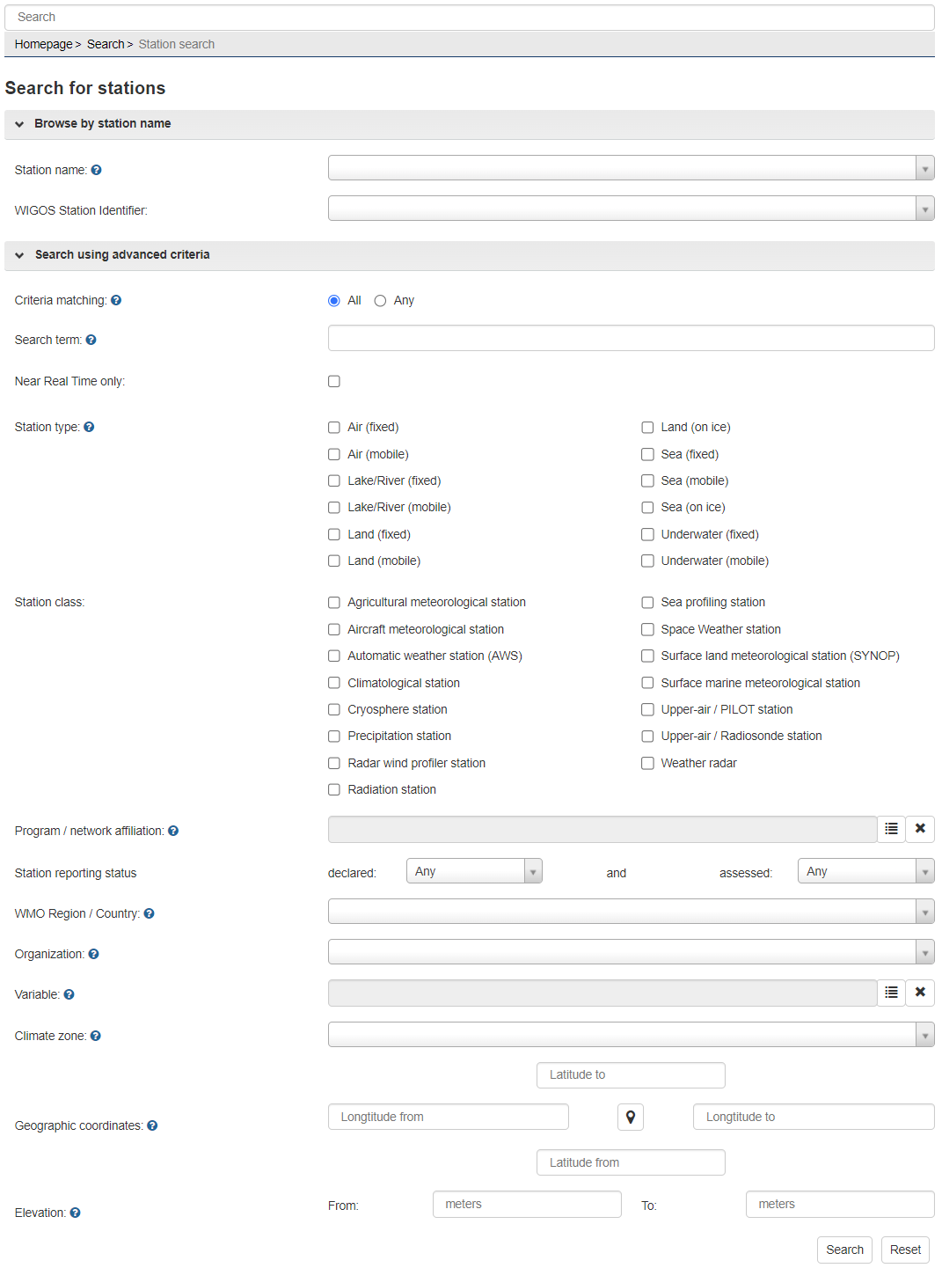

Figure 7.1: The Search page in OSCAR/Surface allowing to search for GBON stations

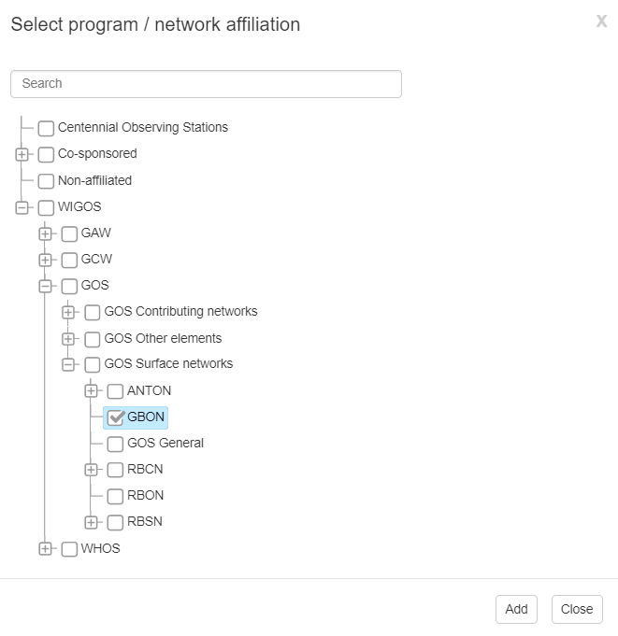

Figure 7.2: GBON selection option under the Program/Network affiliation tree

Figure 7.3: The search result map showing the GBON nominated stations in Switzerland (19 December 2022)

**7.2.2 The metadata details of a GBON station (Station Report)**

By clicking on a GBON station in the search result section or by searching for a specific station, by using the station name or the WIGOS Station Identifier (WSI), the **station report** (Figure 7.4) will be shown. The station report is a collection of all available metadata for the selected station, including the history of changes as documented in [OSCAR/Surface](https://oscar.wmo.int/surface/). The station report is organized into the following five sections: Station characteristics, Observations/measurements, Station contacts, Bibliographic references and documents, all of which can be expanded by clicking on the respective buttons. The station report can be downloaded as a pdf file. A representation of the station can also be downloaded as a WMDR (WIGOS Metadata Representation) XML file.

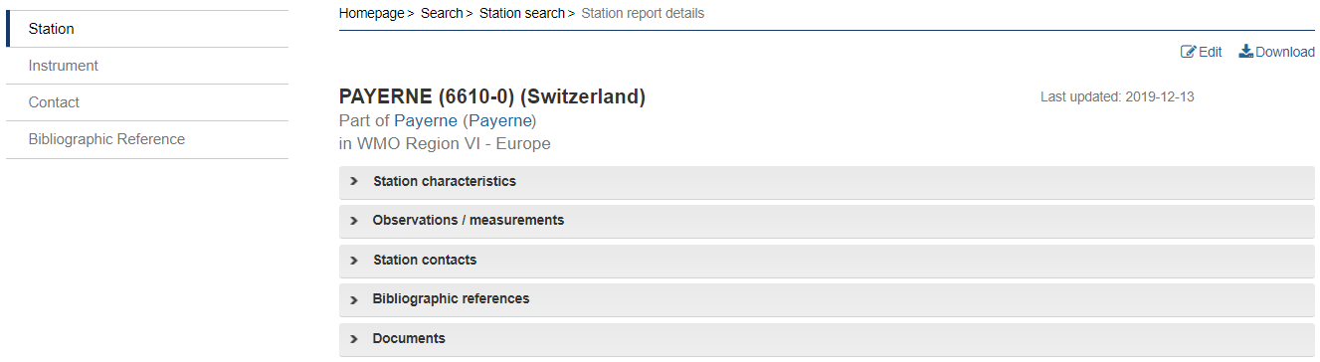

Figure 7.4: The main sections of the station report for Payerne

The “observation/measurements” section of the station report provides information on all variables that are measured at this station and on the Program/networks they are affiliated with, which is available from the section “Station characteristics”. For example, the station Payerne, Switzerland, is affiliated with GBON, as shown in Figure 7.5, while the variable atmospheric pressure is affiliated with GBON as well (Figure 7.6).

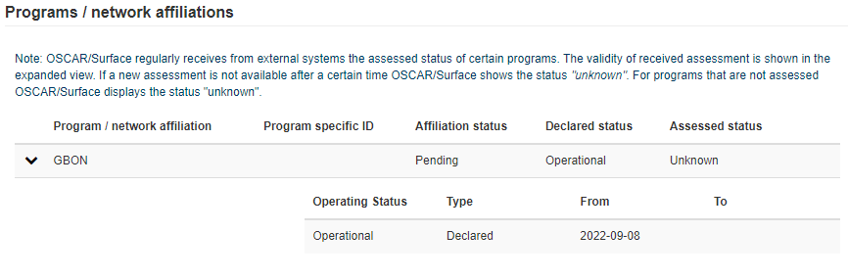

Figure 7.5: The Programs/networks affiliations section of the station report for Payerne

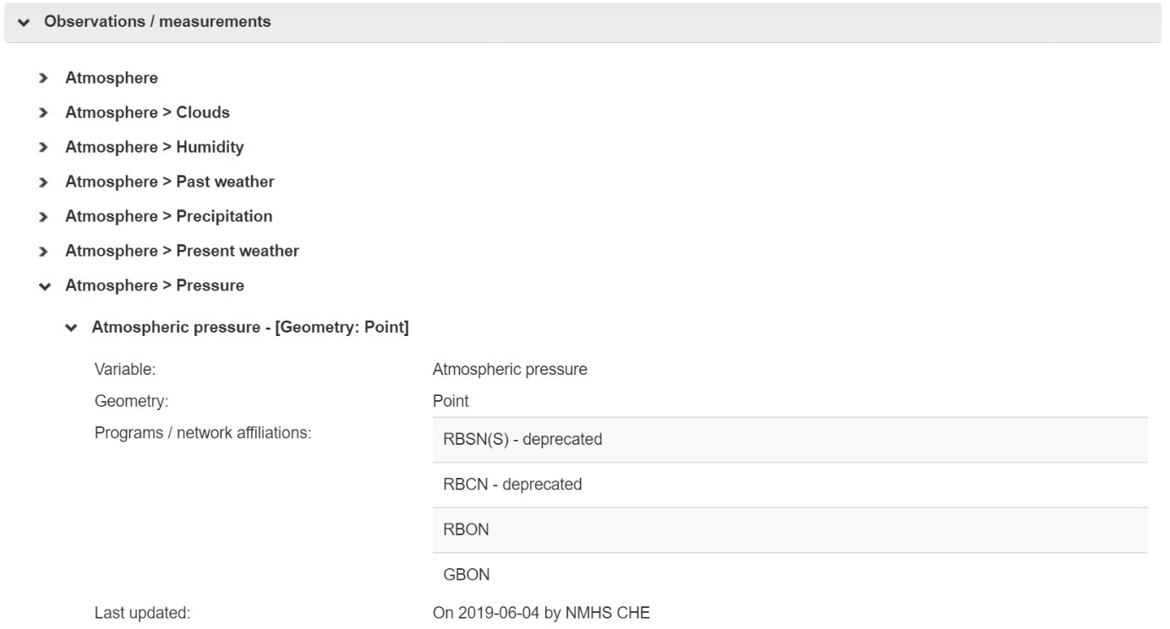

Figure 7.6: The observation/measurements section of the station report for Payerne

**7.3 Registering a new GBON station**

There are several different methods available to register stations which are described in the sections below.

The four different methods of registering stations in [OSCAR/Surface](https://oscar.wmo.int/surface/) include the generic station form, the station templates forms, the Web Client Tool and the XML upload. The generic form offers the possibility to see and manually edit all fields in [OSCAR/Surface](https://oscar.wmo.int/surface/) and is intended for advanced users who want to have full control. The station templates forms make the registration of a new station easier and are intended for users who want to quickly register a station, assuming a set of predefined values for different types of stations templates. The [*Web Client Tool*](https://oscar.tools.wmo.int/web-client) offers the possibility to register a set of stations in an easy and automated way. The XML upload is intended for advanced users of [OSCAR/Surface](https://oscar.wmo.int/surface/) or to exchange metadata information in a machine-to-machine readable format.

**7.3.1 How to use the Generic form to register a new GBON station**

The page of the Generic form is divided into the same five sections as the station report page: station characteristics, observations/measurements, station contacts, bibliographic references and documents. The registered user, normally a OSCAR/Surface National Focal Point,, is allowed to enter/edit the information contained in each of those sections. Some elements, such as the name of the station, are mandatory to save a station in [OSCAR/Surface](https://oscar.wmo.int/surface/). The station cannot be registered unless all the OSCAR/Surface mandatory elements (marked with a single red asterisk) have been provided.

To make a new station, being registered with the generic template, a GBON station, it needs to be affiliated with GBON in the Program/network affiliations section (Figure 7.7). To do so, the GBON entry can be searched in the Program/network affiliations tree after clicking on “Add program/network affiliation”. As a next step all measured variables can be added in the “Observations/measurements” section by clicking on “Add measurement program” (Figure 7.8). The tree search function can be used as well to find variables. After choosing a variable that contributes to GBON, it needs to be assigned as well to GBON by selecting that entry from the available affiliations tree.

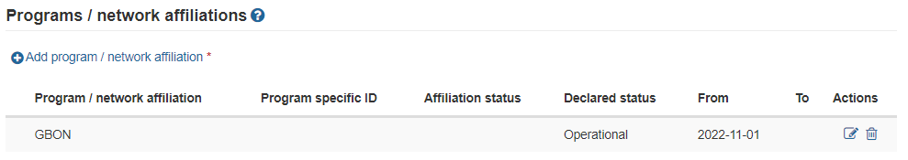

Figure 7.7: The programs/network affiliations section of the generic form

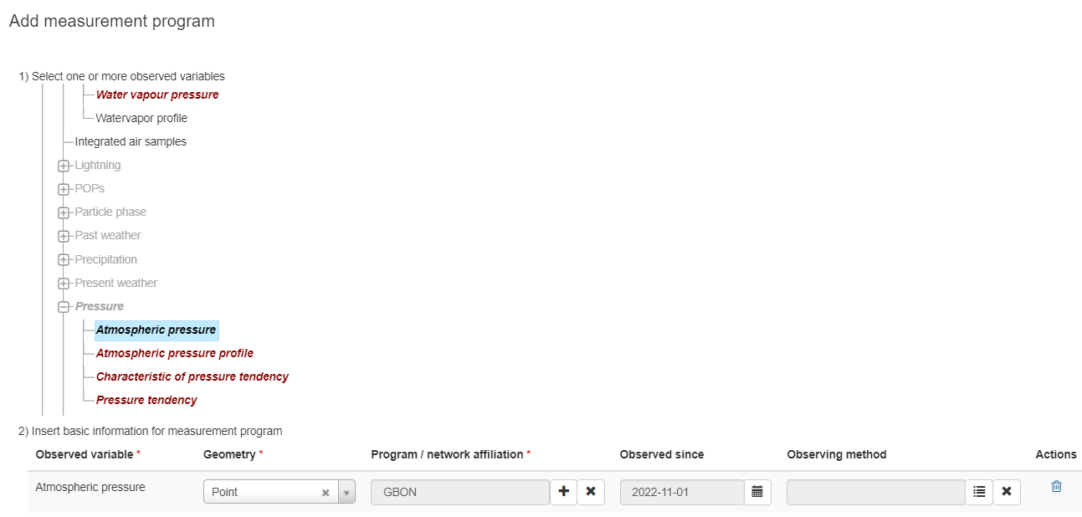

Figure 7.8: The "Add measurement program" window

After adding a variable, the reporting of the measurement must be specified as well. This can be done by clicking on “Add data generation” under the deployment that has just been created. A window will open where the reporting schedule can be defined for this specific measurement (Figure 7.9). For a GBON Surface Land station this should be set to hourly reporting, according to the GBON requirements.

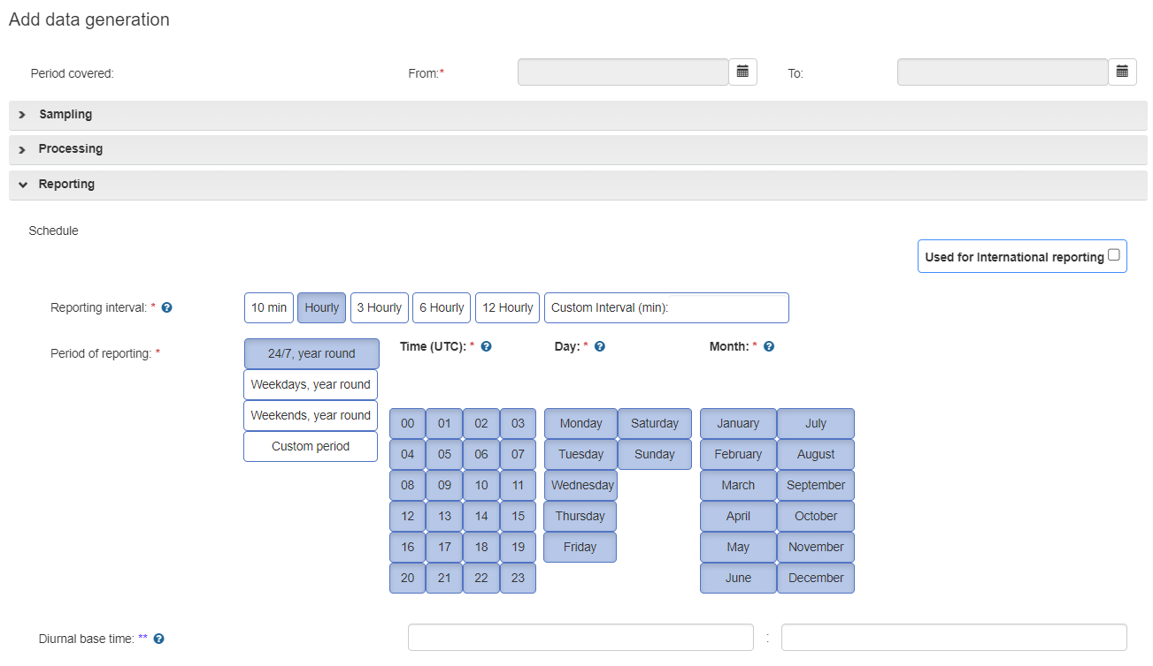

Figure 7.9: The “Add data generation” window

**7.3.2 How to use the station template form to register a new GBON Surface Land station**

To register a new GBON Surface Land station, the GBON Surface Land template can be used. From the list in the management console (Figure 7.10), select the “GBON Surface Land Station” template.

**Figure 7.10: The GBON Surface Land station template interface**

When the GBON Surface Land Station template form is selected, three sections (top, middle and bottom parts of the template) will be shown on the screen, each one containing several with input fields. The top section asks for basic information of the station, that is mandatory to register a station in [OSCAR/Surface](https://oscar.wmo.int/surface/), such as (station) Name, Date established, Country/territory, WSI and (geographic) Coordinates.

The middle section shows the list of all variables that are required to be measured/observed and reported from a GBON Surface Land station, with snow depth being a conditional required variable to stations located where snow is expected. When clicking on the menu button beside each field/variable, the corresponding observing method for each variable can be chosen from a prefiltered tree.

In the bottom section, the reporting schedule can be set by using the schedule interface shown in lower part of the template. According to the GBON requirements, the schedule of a GBON Surface Land station will be set to “Hourly” reporting interval and “24/7, year round” period of reporting.

Completion of the form is confirmed by the “Review and confirm” button. This will display the Generic form with all the information that was entered in the template form, as well as with other automatically prefilled mandatory fields, based on requirements for a GBON Surface Land station, such as the “station type”, the “program/network affiliation”. In the Generic form it is possible to edit any of those fields, and it is also possible to go back to the template form by clicking on “Edit as template”. However, any information that was changed in the Generic form will be lost when going back to the template form.

**7.3.3 How to use the OSCAR/Surface Web Client Tool to register a new GBON station**

The OSCAR/Surface Web Client Tool ([*https://oscar.tools.wmo.int/web-client*](https://oscar.tools.wmo.int/web-client)) is an external application that allows for batch operations. This means that metadata changes in [OSCAR/Surface](https://oscar.wmo.int/surface/) can be applied to several stations at once so that the user does not have to manually enter the information for one station at a time. The current version supports the creation of new stations, changing WSIs, changing schedules and adding Program/networks affiliations, such as to GBON. Details on how to use the Web Client Tool are available in the [*OSCAR/Surface User manual*](https://library.wmo.int/index.php?lvl=notice_display&id=20824#.Y2DnX3bMJPY)*,* section 3.12, the respective webinar on the OSCAR/Surface learning portal under [*https://etrp.wmo.int/mod/folder/view.php?id=15184*](https://etrp.wmo.int/mod/folder/view.php?id=15184) and in the [*video tutorial*](https://vimeo.com/692187140?embedded=true&source=video_title&owner=7296552).

**7.3.4 How to use the XML upload to register a GBON new station**

Instead of using the graphical user interface (GUI) of [OSCAR/Surface](https://oscar.wmo.int/surface/) to register a GBON station, the WMDR XML representation of the station (WMDR XML file) can be used as well. The WMDR XML file for a station can be uploaded by OSCAR/Surface national focal points, using the XML submission of the Management tab of [OSCAR/Surface](https://oscar.wmo.int/surface/) or by the WMDR XML upload REST API. (See 3.10 of the [*OSCAR/Surface User manual*](https://library.wmo.int/index.php?lvl=notice_display&id=20824#.Y2DnX3bMJPY)*)*.

**7.4 Editing the metadata of a GBON registered station**

To edit an already registered GBON station in [OSCAR/Surface](https://oscar.wmo.int/surface/), the same tools as for registering a new station can be used. When using the GUI of [OSCAR/Surface](https://oscar.wmo.int/surface/) an “edit” option appears on each station report in the upper right corner, while being logged on. After clicking on “edit” the generic station form is displayed, containing all station information which can then be edited and saved again. A station, a program/network affiliation, a measurement program, or a deployment could be closed by setting an end date, if necessary. This will make sure that changes to a station are historically recorded. More detailed information on how to edit information can be found in the section 3.7 of the [*OSCAR/Surface User manual*](https://library.wmo.int/index.php?lvl=notice_display&id=20824#.Y2DnX3bMJPY). For the usage of the Web Client Tool or the XML upload to edit station information, reference is made to the same learning and guidance material mentioned in 7.3.3 and 7.3.4.

**7.5 Program/network affiliation of GBON stations**

**7.5.1 How to add a station to the GBON affiliation in pending approval status**

To affiliate a station, that is already registered in [OSCAR/Surface](https://oscar.wmo.int/surface/), with the GBON network, the “program/networks affiliations section” in the station report should be used. In edit mode or when registering a new station, a new program/network can be assigned or an existing one be edited. See also details in 7.3.1 above. After affiliating a station with GBON, it will appear in pending approval status until such request is approved, see section 3.

Besides this approach, the Web Client Tool as well as the XML upload can be used to add a GBON affiliation to a station.

**7.5.2 How to remove a station from GBON affiliation**

***7.5.2.1 Removal from a pending approval status***

Removal of a station affiliated to GBON in pending approval status, can be done by the “Delete” button on the respective line (below actions) in the Program/Network affiliations section. Removal of just a variable can be done by the “Delete” button on the respective line under the Observations/measurements section.

***7.5.2.2 Removal from an approved GBON affiliation***

Removal of a station from approved GBON affiliation can be made in the station report, in edit mode. By using the edit button next to the GBON affiliation in the Program/Network affiliations section, a window is displayed (Figure 7.11), showing detailed information on the GBON affiliation. Another edit button, on the respective status line (below actions) can be used for terminating the affiliation by setting the dropdown menu value to “closed” and by entering a date in the “To” field to indicate the active period of the affiliation (Figure 7.12). After saving the changes, these are subject to approval (see 3.2).

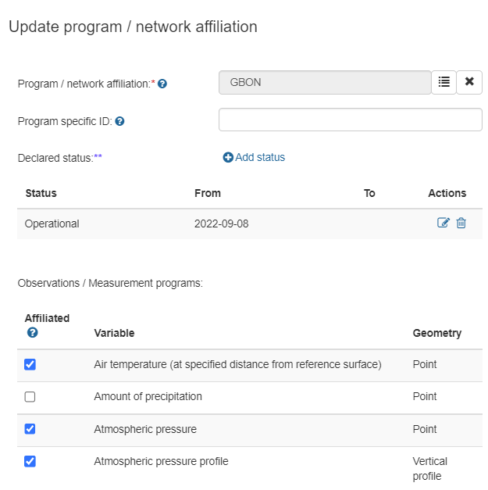

**Figure 7.11: Update program/network affiliation**

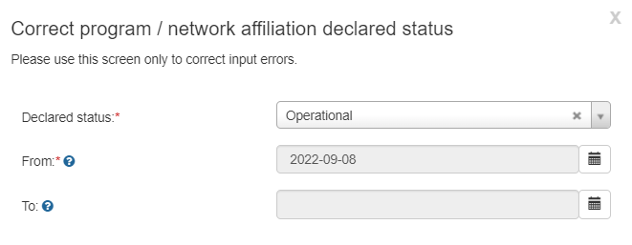

**Figure 7.12: Correct the program/network affiliation declared status**

**Important notes:**

1. Any changes in station metadata are effective only after being saved;

2. The test platform of OSCAR/Surface (<https://oscardepl.wmo.int/surface>) can be used to test updates before making them effective on the operational instance.

8. WDQMS PERFORMANCE MONITORING

The GBON module of WDQMS web tool provides Members timely feedback about the station-level performance in relation to the GBON provisions. The system is based on the GBON compliance criteria adopted by INFCOM. The GBON module of WDQMS web tool also provides the quantitative data which contributes to the Member level GBON compliance monitoring.

More information about the GBON module of WDQMS web tool can be found in the [WDQMS Online user guide](https://confluence.ecmwf.int/display/WIGOSWT).

______________

1. High density requirement is mandatory for data exchange where capability exists. See details in the section 2.2.
2. Requirement is mandatory for data exchange where capability exists.
3. Monthly aggregation of observed variables from surface observation [*Secretariat]* reports, received by at least one [*Secretariat*] of the NWP centres monitored by WDQMS web tool
4. If a station is manually operated but is not operational 24 hours, this number can be reduced to the operational hours (hourly reporting i.e. 0800 – 1700 = 10 reports) as recorded in OSCAR/Surface. This needs to be registered as an exception to GBON regulations
5. Monthly aggregation of reports that missed time cut-off from NWP centres/WIS
6. Monthly aggregation of rejected reports from NWP centres, could also be gross errors or outside of OB-FG threshold
7. Monthly aggregation of observed variables from upper-air observation [*Secretariat]* reports, received by at least two of the NWP centres monitored by WDQMS web tool
8. If a radiosonde station is only able to undertake one sounding per day, this number can be reduced to the scheduled as recorded in OSCAR/Surface. This needs to be registered as an exception to GBON regulations
9. High Resolution data (BUFR) being received confirmed by at least one [*Secretariat*] of the NWP centres monitored by WDQMS web tool
10. Monthly aggregation of reports that missed time cut-off from NWP centres/WIS
11. Monthly aggregation of rejected reports from NWP centres, could also be gross errors or outside of OB-FG threshold